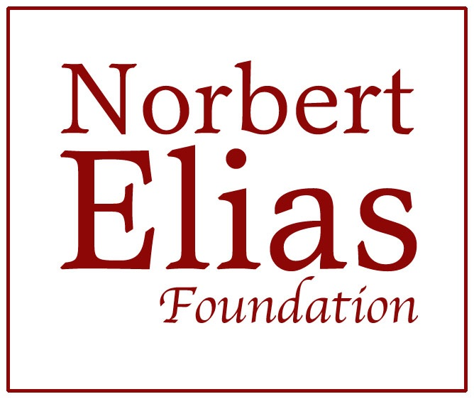 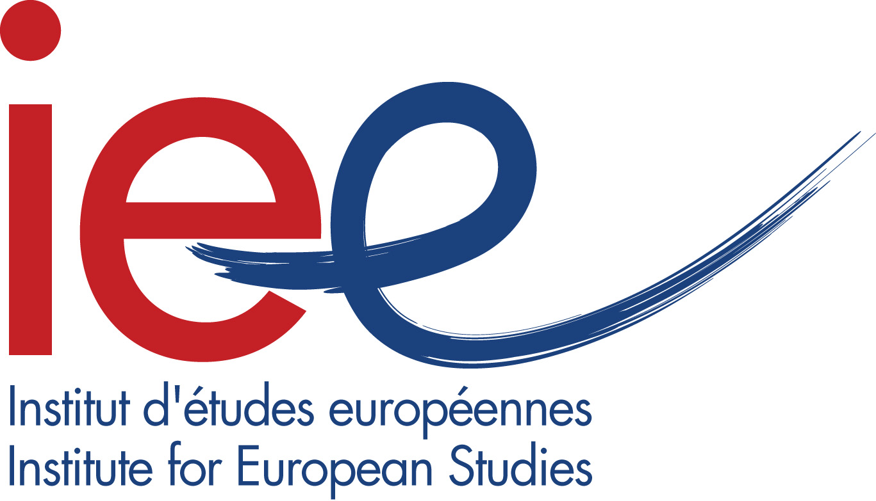   

**Global Interdependencies**

**What’s new in the human society of individuals?**

The political and academic relevance of Norbert Elias’s work today

Brussels, Université Saint-Louis – Bruxelles

5–8 December 2018

The **Research Centre in Political Science** (CReSPo) and the Institute for European Studies (IEE)of Université Saint-Louis – Bruxelles (USL-B) are organising the next Elias conference in Brussels, Belgium, on 5–8 December 2018. This conference results from collaboration between Florence Delmotte (Research Associate at Belgian Fund for Scientific Research – FNRS and Professor of Political Science at USL-B), Stephen Mennell (Professor Emeritus of Sociology at University College Dublin), Jason Hughes (Professor and Head of School of Media, Communications and Sociology, University of Leicester) and Barbara Górnicka (School of Sociology at University College Dublin).

**Abstracts** for papers of no more than 400 words should be submitted not later than 15 May 2018. Every effort will be made to accommodate contributions by all scholars who are making serious use of the ideas of Norbert Elias in their research.

Submissions should be sent to the conference email address: [EliasBrussels2018@gmail.com](mailto:EliasBrussels2018@gmail.com)

Fort further detail, see the conference website: <https://eliasbrussels2018.wordpress.com>

Contacts: [florence.delmotte@usaintlouis.be](mailto:florence.delmotte@usaintlouis.be) (Principal Organiser);

[anne-alexandra.fournier@usaintlouis.be](mailto:anne-alexandra.fournier@usaintlouis.be) (Venue Contact).

**Short presentation of the Conference**

*‘Some of my readers may perhaps wish me to tell only about aspects of humankind’s development that are pleasant and hopeful. But such a selection is the true meaning of the* trahison des clercs*. We may or may not welcome the increasing integration of humankind. What is quite certain is that, to begin with, it increases the impotence of the individual in relation to what is happening at the top level of humanity’* (Norbert Elias, Changes in the We-I Balance [1987], *The Society of Individuals*, Collected Works 10, UCD Press, 2010: 149).

Thirty years later it seems that nothing has happened to contradict the assessment of the increasing integration of humankind as being a major trend, or more exactly that ‘integration–disintegration tensions’ are part and parcel of the contemporary world. However, we have more difficulties in imagining how it would be possible to see only the ‘pleasant and hopeful aspects’ of human development or even what they finally are. Global warming, refugee crises, the rise of populisms and finally the explosion of old and new forms of war and terrorism: Elias was right to wonder whether humankind would survive the violence of his time and ours.

The next Elias Conference in Brussels will be an important opportunity to explore the political topicality of process sociology and to learn from Norbert Elias’s analysis and intuitions to think about (de-)democratisation, (dis-)Europeanisation and Brexit, (de-)civilizing processes in America in the Trump era, or facing the tragedy of migrants in Mediterranean, among other signs of civilizing breakdowns, or at least potential breakdowns or counter-processes. This conference also aims to open new fields of discussion and to consolidate and enlarge the already existing research networks among Elias’s fellows and readers of all countries, disciplines and generations. In the light of today’s crises, following Ghandi’s famous comment upon being asked ‘What do you think about Western civilization?’ He replied. ‘I think it would be a good idea’ – the perspectives from the Global South on Western civilization could prove to be particularly valuable.

The conference will also include a Special Session on ‘Process Sociology and Processual Sociology’, centred on the work of Andrew Abbot and his book *Processual Sociology* (University of Chicago Press, 2016), exploring the ways in which his thinking and that of the Elias research tradition are complementary (or otherwise). Professor Abbott has agreed in principle to take part in the conference, although it is too early to confirm that that will prove possible. With or without his actual presence, this will be an unprecedented opportunity for dialogue between different horizons of research.

The conference will be preceded by a PhD workshop on 4–5 December 2018 organised by Professors Robert van Krieken and Stephen Mennell for PhD students interested in integrating civilizing processes and historical sociology perspectives into their research. Further information about this will be widely circulated in spring 2018.

**Call for sessions and papers**

The conference in Brussels will aim to question current global, regional or local political issues through examining the processes involved in historical and developmental sociological perspective: that is to say, it will aim to consider short-, mid- and long-term social processes without disconnecting the analysis of the political (polity, politics or policies) from the other aspects of the public and private human social life and their multilevel interactions.

**1. Global Interdependencies**

***1.1. Functional Democratisation and Functional De-democratisation***

The question of whether Elias was too confident and sweeping in seeing ‘functional democratisation’ as a dominant trend in the modern world has been much discussed recently by, among others, Stephen Mennell, Nico Wilterdink and Behrouz Alikhani. Does this trend co-exist with a counterpoint of ‘functional de-democratisation’? This ‘theoretical’ question also has very practical, empirical dimensions, as can be seen in the following suggested thematic sessions:

***1.2. De-democratisation, Habitus (and Brexit) in the European Union and beyond***

Elias pointed out that increasing integration cannot be confused with ‘progress’, but he did not really answer the question of what could be the significations of ‘progress’. Today, one can have the impression of many regressions, even considering a rather neutral conception of ‘integration of human kind’. In this session, papers are expected to explore rise of new and old forms of nationalisms and the question of the crisis of democracy, especially in the European Union and regarding its representative forms.

***1.3. Uncertainty and the Rise of Populisms***

In the following, the conference will ask the question of the populisms today, which are not to be confined to the traditional extremes – if they have ever been. How can we understand and explain new growing success of extreme right, extreme left and more broadly of radical populist political parties in old and new European democracies and in Latin America? To what extent and through which ways should the mainstream quantitative and behavioural standards of political sociology be renewed? Which deep-set global trends are to be considered? How can we explore dynamics behind the success of populist parties and leaders at a micro level? And what could possibly the consequences of such successes be across different countries? It is within this context too, that reconsidering of Elias’s ‘drag effect of national loyalties’ concept would seem particularly stimulating and appropriate.

***1.4. Terrorism, Violence, Anger and Fear***

Violence is a main topic for sociology of civilizing and decivilizing processes. Papers are invited to concentrate on the multiple forms and on the origins of what is properly or wrongly called terrorism today. In particular, the recent attacks in Nice (2016), London or Barcelona (2017) revealed the importance of new modus operandi that seems to signify a step back from more organised and centralised forms of attacks. How can we interpret them? How do people react to them? And how can we significantly relate these phenomena of long-trend and more recent evolutions at work in the Middle-East, Asia and Africa – and Europe? This session is particularly opened to any kind of interdisciplinary dialogue, from international relations to psychology.

***1.5. Borders, Migrations, Security and ‘Refugee Crises’***

Irreducible to the monopolisation of violence, the state is another core concept of historical sociology. For some it has however be overcome in its bordered and national forms by globalisation and quite recent forms of regional integration, for instance at the European level. For the two last decades border studies and critical security studies have at the same time demonstrated that far from disappearing the importance of borders and of new security issues have been revealed by the achievement of globalisation. How the concept of state as fostered by process sociology is thus affected by this apparent contradiction? How can we rethink citizenship and tensions over the value of the nation-state in such paradoxical context? In this session, papers are also invited to address the role of rights and law in process sociology, and to investigate these questions sociologically ‘from below’ and/or at the level of the ruling elites.

***1.6. The Role of Utopias***

The conference will be interested in re-exploring the roles of utopia, in politics and social sciences and in fostering the dialogue between apparently very distant approaches in philosophy and sociology. In particular, could the global utopias – from the ‘perpetual peace’, to the Human Rights – be a medium connecting more descriptive, comprehensive and reconstructive perspectives, on the one hand, and those that would be more prescriptive, value and action-oriented on the other hand?

**2. Additional sessions**

***2.1. Elias and Social Dynamics of his Time*** (a session proposed by Adrian Jitschin)

The theory of Elias developed in a specific social environment. Elias was socialised during the final stages of the German Empire and over the course of the Weimar Republic. This was a period of turmoil and competition between ideas: liberal, socialistic and nationalistic positions strove for followers. The political environment was fluctuating. Several of Elias’s teachers and acquaintances were engaged in these disputes. The session is intended to illuminate some of these persons, ideas and positions. The activities of that period should be explained by papers who examine a specific aspect and its relevance for Elias: for example a concept (*Freischwebende Intelligenz*, Freemasonry, Zionism) or a person (Alfred Weber, Richard Hönigswald, Siegfried Marck). Together, the papers should give an impression of Elias’s embeddedness as a European intellectual.

***2.2. Re-Figuration of Space*** (session organizers: Nina Baur, Linda Hering, Theresa Vollmer and Gunter Weidenhaus)

Norbert Elias is usually seen as a pioneer in process sociology. Meanwhile, it is often forgotten that he also pioneered spatial sociology both on the macro-level (e.g. concerning the process of nation-building in *On the Process of Civilisation*) and on the micro-level (e.g. on the relevance of architecture for reflecting and pre-structuring social interaction in *The Court Society*). Today, owing to processes such as digitalization and mediatization, globalization and the rise of local contexts as well as migration, spatial relations that formed during modernization and have been established since then seem to be dissolving and replaced by new forms of spatial relations. In this session, papers are expected that explore these new forms of spatial relations, that explain current process of spatial re-figuration or that examine how spatial re-figuration changes society.

***2.3. Furthering Process-Oriented Methodology: Towards Process-Oriented Micro-Macro-Analysis*** (Organizers: Nina Baur, Lilli Braunisch, Jannis Hergesell and Maria Norkus)

Many of the current sociological methodological and theoretical approaches are best suited to analysing individual behaviour. However, as methodological discussion in the last decade has shown, research in the tradition of figurational sociology needs a process-orientated micro-macro-analysis which is comparative and typically mixes historical methods, quantitative methods (e.g. surveys) and qualitative methods (e.g. ethnography). While current social science methodology provides valuable tools for such an analysis, many methodological questions for research in the Eliasian framework remain open, and papers in this session should address one of these issues, amongst them: how to assess causality; how to define the defining the population/field of analysis (i.e. figuration); how to conduct a temporal sampling for process-orientated methodology; and how to find an equivalent for ethnography in historical research.

***2.4. Expressions of suffering and ways of dealing with it in the society of individuals*** (Organizer: Nicolas Marquis, Université Saint-Louis – Brussels)

The hypothesis of this session is that both expressions of unease or suffering and the ways we deal with it are fundamentally social, even if they nowadays use the language of the individual (for example in the self-help literature, in the neurosciences, in psychiatry). They both are what may be called social institutions of individualism. Their analysis may help understand what living in an individualistic society means.

Papers for this session may be theoretical or empirical. They are expected to focus on expressions of suffering (for example in the areas of health, mental health, poverty and social issues) by various actors (professionals, patients, clients) and/or the way(s) they are dealt with. What kind of individual or collective devices are imagined by professionals (self-help, training and exercises, fostering the knowledge on oneself)? What kind of language games are used to explain the interest or efficiency of these devices (“work on the self”, “care”, “empowerment”, “capabilities enhancement”)?

***2.5. The re-figuration of public communication in times of deep mediatization: Pioneer journalism, audience relationships and public connection*** (Organizers: Andreas Hepp, University of Bremen, ZeMKI, Uwe Hasebrink and Wiebke Loosen, Hans-Bredow-Institute Hamburg)

As a consequence of ‘deep mediatization’ (Couldry/Hepp 2017) – the increasing entanglement of the social world with digital media and their infrastructures – public communication has fundamentally transformed. These changes can manifest themselves in negative ways such as metric-driven journalism, fake news, or silos of media use. But they have had positive manifestations such as investigative forms of data journalism. The idea of this session is to take a figurational approach to empirical research on public communication. We invite papers taking a figurational approach to following topics:

* new forms of journalism, for example, data-driven or algorithmic journalism that emerge beyond the purview of established media organizations, disrupting journalism’s organizational figurations.
* journalists’ relationships with their audiences as a figuration, that fundamentally transform with deep mediatization, a process that influences their work and output in many ways.
* users’ public connection perceived as a communicative figuration, based on highly complex media repertoires.

***2.6.* *Accelerating Habitus Shifts and Long-Term Alternatives*** (Keynote: Peter Ludes, Chairs: Profs. Herzog, Shanghai, and Kramer, Cologne)

Ever newer dis-/information and ex-/communication technologies accelerate habitus shifts (Ludes 2017), “rated as either positive or negative and distilled into a single number ... underway in China.” (Botsman 2017) Such habitus shifts must be taken into account by any re-/search for process-adequate social alternatives, beyond utopias. (Elias 2013) Alternatives as “desirable, consistent and realizable” social actions, processes, or structures different from the predominant ones clarify behavior and development scopes, realize unchangeable constraints, driving forces, and the synchronization of partial social processes, advancing, reverting or radically transforming in distinct speeds and rhythms. (Ludes 1989) Long-term alternatives call for the improvement of, e.g., self-control and detachment and need the clarification of algorithmic dis-/orientation.

***2.7. Using Elias’ model of ‘Established-Outsiders’ in social research*** (Organizer: Gunnar Olofsson)

This session will be devoted to one of Elias’ imaginative and important conceptual innovations, the dynamic model of ‘Established-Outsiders.’ Elias’ relational concept goes far beyond thinking in terms of majority-minority. It has been, and can be, used for analyzing power relationships between social groups in many different social settings, such as gender, social class and ethnic conflicts and relations. We especially invite papers that present empirical analyses that apply, discuss and develop the Established-Outsiders model.

***2.8. Norbert Elias’s Ghanaian Papers***(Organizers and speakers: Behrouz Alikhani, Münster, Arjan Post, Amsterdam, Adrian Jitschin, Frankfurt, and Dieter Reicher, Graz).

In this group discussion, pre-selected experts will discuss validity and quality of papers written by Norbert Elias during his professorship at the University of Accra. Those manuscripts were found in the Archives of Marbach. Elias had the intention that they should become a book about the African civilising process. He never finished this book despite he returned to work on the project in the 1980s. We will discuss the possibility to edit and publish this material in a publication about Elias's approach towards non-European societies. Participants are invited for discussing after the exchange of the experts.

***2.9. On the long-term processes of Civilisation and Informalisation. Connecting social and psychic processes*** (Organizer : Cas Wouters)

This session aims to present and discuss themes developed in the reader “On the long-term processes of Civilisation and Informalisation” (Michael Dunning, Wilbert van Vree, Arjan Post, Richard Kilminster, Raùl Sanchez, Jon Fletcher and Cas Wouters). This reader presents the perspective that the transition in dominance from formalisation to informalisation around the 1880s represents a breakthrough in human history, as a consequence of which the long-term civilizing process came to consist of two subsequent long-term phases, first a phase of formalisation of steering codes and then a phase of informalisation. The authors focus on various walks of life, on sex, love, mourning, photography, sports, jihadism, meetings, immigration, globalisation and evolution, thus illuminating many part-processes of an encompassing long-term process of informalisation.

Papers are invited that go along or against this view and these topics; the organizer hopes to pay attention to two specific topics:

1) Connections between globalization, informalisation, and functional democratization, raising three questions: To what extent have processes of informalisation and functional democratisation extended to the global level? Have these processes stalled, come to an end, or changed direction? And have the processes driving them, those of social differentiation, integration, and complexification stalled, come to an end, or changed direction?

2) The wave of protest by the #MeToo movement. The latter has broken a major stronghold of the regime of silence dominating all forms of sexual intimidation: internalised shame resulting from ages of shaming the victims. Will the #MeToo movement also increase the chance that a type of mutual consent develops that includes ‘being ready for the experience’ and that mutual attraction becomes integrated with mutual consent to the extent that both develop into a taken for granted condition for all sexual pleasure? This session aims at examining this question Too.

**3. Open Fields**

Beside the more specific ‘political’ topics, the next Elias Conference in Brussels will draw special attention to the interdisciplinary dialogue and the use of mixed methods, plural temporalities and different approaches (political/macro/global ones and more micro-sociological) in usual or less usual fields in process sociology. Whatever the topic, the papers are thus also invited to reformulate in a more reflexive way a series of sociological issues traditionally considered by process and historical sociology, in matter of urban development, sport, violence, or gender studies, but also on the subjects of intimacy, celebrity, religiosity, health and care, fashion or art. Propositions are expected, for instance, around these themes:

***\* Processes and the City***

***\* Established and Outsiders and Social Inequalities Today***

***\* How to Use the Classics in the Present Day***

*\*****Sociology, History, Philosophy, Law, Political Science and Psychology: Is Interdisciplinary Dialogue just a Myth?***

***\* Working with Elias Yesterday, Teaching (with) Elias Today: Narratives and Testimonial***

A round table will be dedicated to sharing experiences and testimonies of working with Elias and learning directly from him. Elias conferences are always rich indeed in related experiences that are often ‘distilled’ among *Figurati* around a dinner table or in a pub. Why not share more broadly such precious and often highly significant anecdotes in order to promote the sharing of knowledge and to foster a broader and more open research culture? In the same spirit, another round table aims at bringing together professors and teachers-researchers working on Elias with their students today or using some of his concepts and methods in their courses.

***\* Special Session around Andrew Abbot’s work and book* Processual Sociology – see above**

**Organisation of the conference**

This conference results from collaboration between Florence Delmotte (Research Associate at Belgian Fund for Scientific Research – FNRS and Professor of Political Science at USL-B), Stephen Mennell (Professor Emeritus of Sociology at University College Dublin), Jason Hughes (Professor and Head of School of Media, Communications and Sociology, University of Leicester) and Barbara Górnicka (School of Sociology at University College Dublin) with the support of Université Saint – Bruxelles, the Fund for Scientific Research-FNRS, Belgium, and the Norbert Elias Foundation in Amsterdam.

Members of the Organising Committee in Belgium are Prof. Denis Duez (President of the European Studies Institute, USL-B, Brussels), Anne-Alexandra Fournier (Research Management and Administration) and Nicolas Marquis (Professor of Sociology, Université Saint-Louis – Bruxelles).

International members of the Scientific Committee are: Behrouz Alikhani (Westfälische Wilhelms-Universität Münster), Nina Baur (Technische Universität Berlin), Reinhard Blomert (Wissenschaftszentrum Berlin für Sozialforschung), Manuela Boatca (Universität Freiburg), Karina Caplan (Universidad de Buenos Aires, Argentina), Paddy Dolan (Dublin Institute of Technology), Ademir Gebara (Universidade Federal da Grande Dourados), Cynthia Greive Veiga (Universidade Federal de Minas Gerais, Brasil), Johan Heilbron (Research Director at CNRS, France), Erik Jentges (ETH Zürich), Adrian Jitschin (Norbert Elias Foundation), Marc Joly (Researcher at CNRS, Laboratoire Printemps/UVSQ, France), Andrew Linklater (Aberystwyth University), Katie Liston (University of Ulster), Angela Perulli (Professor of Sociology at Università degli Studi Firenze), Robert Van Krieken (University of Sydney), Vera Weiler (Universidad Nacionalde Colombia) and Gina Zabludovsky (Universidad Nacional Autónoma de México).

Members of the Scientific Committee from Belgium are: Prof. Christine Schaut (Professor of Sociology, Université libre de Bruxelles and USL-B), Ludivine Damay (Professor of Sociology and Political Science, Université libre de Bruxelles), Jean-Michel Chaumont (FRS–FNRS Research Associate, Université catholique de Louvain), Virginie Van Ingelgom (Research Associate at FNRS and Professor of Political Science, Université catholique de Louvain Pierre Desmarez (Professor of Sociology, Université libre de Bruxelles) and Marc Zune (Professor of Sociology, Université Catholique de Louvain).